**PLUGIN PROGRAMMING IN WORDPRESS**



Student Name: **Xuan Hai Nguyen**

Student ID: **12885170**

Teacher: **Laura Antochi**

Subject: **ICT 1**

Dear Laura,

As the requirement, the report of “*Plugin programming in WordPress”* which is the topic relate to the ICT 1 project is selected*.* The purpose of this report is present the overall of Plugin and how powerful of Plugin in WordPress is. Also based on the features of Plugin, giving case study to apply our Project.

Thank you for spending the time on my report. I am looking forward to hearing your feedback as soon.

Regard,

Hai Nguyen.

Table of Contents

Executive Summary 4

INTRODUCTION. 5

I. Chapter 1: OVERVIEW THE PROGRAMMING OF PLUGIN FOR WORDPRESS. 6

1.1.What is Plugin: 6

1.2.Why have to use the plugin. 6

1.3.The necessary knowledge before starting 6

1.4.APIs are available in WordPress 7

1.5.Plugin location is loaded in process 8

1.6.The advantages of the plugin in WordPress 9

1.7.The best Plugins make WordPress stand the 1st position in blogging sources 9

1.7.1. Plugins for enhanced confidentiality. 9

1.7.2. Plugins for SEO. 9

1.7.3. Plugins for connecting WordPress and Google. 10

1.7.4. Plugins for sales sites 10

1.7.5. Plugin for creating form 10

1.7.6. Plugin Backup and Restore for WordPress 11

1.7.7. Plugin Lazy Load for WordPress speed. 11

1.7.8. Plugins to Detect Malicious Code for WordPress Security 11

II. Chapter 2: CASE STUDY 12

2.1.Home Page: 12

2.2.Registration Page: 12

2.3.Contact Us Page: 14

III. Chapter 3: UNDERSTANDING PLUGIN 15

3.1.Starting write Plugin for *“Simplr User Registration Form Plus”*. 15

3.2.Writing code for Plugin. 17

3.3.Complete and Upload Plugin to WordPress. 18

3.4.Testing Plugin: 18

CONCLUSION. 19

RECOMENDATIONS. 19

REFERENCES 19

# Executive Summary

Nowadays with the development of the economy, culture, society led to the booming of information technology. Therefore, the demand of information communication technology (ICT) which is sharing information to connect between both businesses and consumers is absolutely necessary. To satisfy that demand, the Website was created to serve for companies, enterprises or individuals and website building is become popular for individuals or groups on the Internet environment. There are many ways to built the Website, the enterprises, individuals can hire external business partners or can do it by themselves using the open sources systems available. WordPress is one of them. With a visual interface, easy to use and satisfy the basic or advance needed of an individual or group, WordPress has been widely used and got positive feedback from many designers.

Plugin is a major component to create the strength for WordPress. To create SEO for the Websites, we need to have Plugins, to create Pop – up, also need the Plugin or to create the features for the sale website must use Plugin, etc. It can be said, Plugin is considered as the power supplement details for WordPress.

# INTRODUCTION.

In 2003, WordPress was released by Michel Valdrighi based on b2/cafelog. After the release, WordPress has had over 2000 blogs use. A few years later WordPress has made great progress shown in the huge warehouses Plugins and Theme with a lot of customization (Sabin-Wilson, 2011). According to the statistic of Pingdom company in 2012, WordPress dominated sources code blog with 48% of the 100 most popular blogs worldwide in 2009 and completely dominated the top 100 blogs.

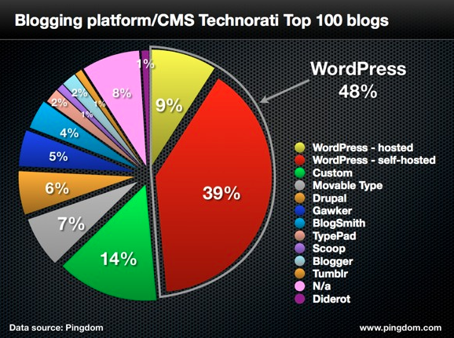

*Figure 1.1: Blogging platform/CMS Technorati top 100 blogs* (PINGDOM, 2012)

Plugin is the most important component using in WordPress. There are the huge warehouses plugin in WordPress and also can write by own plugin.

WordPress system owns more than 38 thousand kinds of plugins and over 950 million downloads, this is indeed too horrible numbers (WordPress). The message is showed in the figure below:

*” Plugins extend and expand the functionality of WordPress.* **38,463** *plugins with* **958,462,368** *total downloads are at your fingertips”*

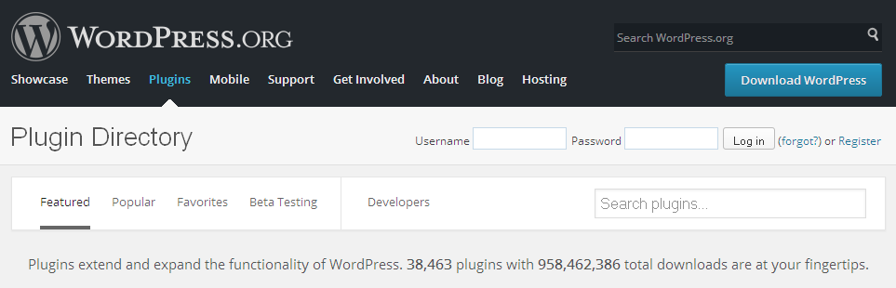

*Figure 1.2: Plugin directory (source: WordPress)*

However, in this report is going to explore the overall of plugin and the importance as well as its influence in helping WordPress ranked the first position in the ranking of source blogging. Many plugins can intergrade and use on a blog run by WordPress, it will become an improvement overall, great functionality expectations.

# Chapter 1: OVERVIEW THE PROGRAMMING OF PLUGIN FOR WORDPRESS.

## What is Plugin:

Plugin is a software, which include one or more PHP file containing multiple commands or function written by user or legacy available functions from the library of WordPress.

With this plugin repository, you will easily find a satisfied plugin by systems that support assessment ranking by the popularity of plugins or plugin arrange according to each function. (Balkhi, 2009)

## Why have to use the plugin.

Plugin is a heart of WordPress. You can not use WordPress without plugins. There are many plugins for various purposes, providing the user with a number of functions and certain utilities. You can search plugin to serve some of your interests or That plugin will make managing your blog better. For example, such as WordPress SEO plugin will help you more easily in the SEO for WordPress blog.

## The necessary knowledge before starting

* HTML and CSS
* PHP
* MySQL, JavaScript
* Action Hook and Filter Hook

There are the basics knowledge necessary for programming Plugin before starting

**Tools support:**

* Software supports PHP: Notepad ++ or Sublime Text 2
* Simulator localhost: XAMP or MAMP
* A WordPress blog was installed on localhost.

Localhost installations on the computer will help for testing before upload to hosting. Also, it will help avoid to upload to hosting many times and avoid lost or damage site for who has no experience in writing plugins.

## APIs are available in WordPress

* **Plugin API**

Plugin API is a set of hooks which the Plugin can attach into and extend them out.

Plugin API provides the hooks and allow it access to the WordPress system.

There are two different types of hook: **action hook** and **filter hook**. (Suharto, 2011)

* **Action Hook:** allows to activate the supplement of plugin code at the specified location in the process of working with WordPress.
* **Filter Hook:** has the task of helping to change the content of the articles before saving it into the database.
* **Widget API**

Widget API support for creating widgets on the website. It can be found in the meta, the category, the comments on the website, which is the widget default by WordPress.

Widget API can be used to create widgets according to own intentions. (Brazell, 2011)

* **Shortcode API**

Shortcode API is a short piece of code that you can insert it into the body of the section Posts or sections Pages of WordPress system, which means when you post new content and insert shortcode into, WordPress will read shortcode then call to the plugin generated that shortcode and displayed for the purpose of shortcode. (Prelovac, 2009)

* **HTTP API**

HTTP API to help get data or send data from our website to another site.

That Plugin list does not exist in the source of WordPress that we download on, it comes from the homepage wordpress.org, the data obtained from the parent site is through the HTTP API. So when WordPress notification to upgrade system, then you will also receive notifications from it. (Wang, 2012)

* **Settings API**

Settings API is a set of function supported set of values located inside the the Settings menu in the admin page. (Codex, 2014)

* **Options API**

Options API provides methods and these methods will be used to store data on the table options in the WordPress database. This API is usually used in parallel with the Settings API to create new pages in the admin page. (Ratnayake, 2015)

* **Dashboard widget API**

Dashboard widget API methods are helping to create the block in the admin page, which means that can be programmed in the main page, add the block displays a list of orders, most viewed articles, etc. (Ratnayake, 2015)

* **Rewrite API**

Rewrite API helps you change the links and make us become more friendly with search engines like Google, Bing, Yahoo, etc. (Ratnayake, 2015)

* **Transient API**

The mission of this API is to support creating temporary data stored in the system to reduce the load of the data processing of WordPress system, make website run faster. It is similar in PHP caching techniques. (Ratnayake, 2015)

* **Database API**

Database API is a combination of many different APIs. The API that will assist in the process of retrieving data from the database of WordPress. (Olinik, 2011)

## Plugin location is loaded in process

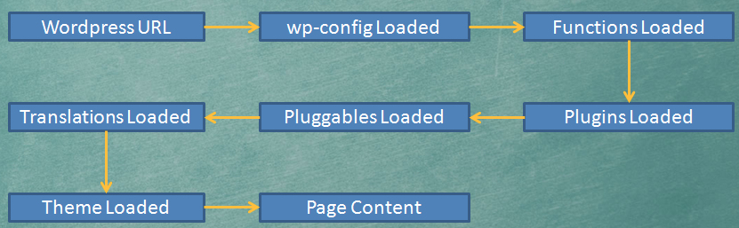

*Figure 1.3: Plugin location in load process (source google)*

The chart shows the operation to load the data:

* Starting with WordPress URL, it will load the configuration in wp-config file. Then it loaded to the configuration in the WordPress database.
* After that, it will call the function which is the main processor in the core of WordPress.
* It continues load the whole Plugin into the system but the Plugin does not work because it only works when the system calls to action hook or filter hook on WordPress
* Then it will be loaded to the main method in pluggable.php file, this file is located in the folder wp-includes.
* Next, it will load the language format and themes have been processed. Finally, display all the content website through the page content.

## The advantages of the plugin in WordPress

* One of the main advantages of the plugin in WordPress system is the ability to change the process of WordPress that you do not need to modify any files in the WordPress
* Another advantage is that can reuse the methods and APIs already exists in WordPress to develop your plugin.
* Easily inherit and edit available plugins.
* Easily upgrade to fix the errors in older plugin version to secure a website better.
* **Plugin Sandbox** is a secure area. When your plugin violates laws or cause errors to the WordPress system, the system will automatically move your plugin on this area.

## The best Plugins make WordPress stand the 1st position in blogging sources

### Plugins for enhanced confidentiality.

Default WordPress does not help you to protect folder that are important, so you should to create an index.html or index.php file and put it in folder empty inside wp-content / plugins /. if Hacker know which Plugins you are using, they will take advantage of the error in that Plugins to attack you. (Blog Security have given some mistakes were dangerous to Plugin like: *WP-Forum 1.7.4, WP-File Manager <= 1.2, 2.0.1 Democracy, WP TextLinkAds, Captcha Audio System*, etc.

One of the ways to against hackers is to combine with Michael's Login Lockdown plugin allows limited ability to hack passwords by trying to duplicate or dictionary attack. If the password is entered incorrectly a certain number of times, it will block that IP within a period of 1 hour follow the default configuration.

### Plugins for SEO.

* Optimized title and meta description tags: by using **SEO Ultimate** Plugin which can create functions in two different content at title tag and meta description, this helps to describe more fully and accurately about your posts.
* Protect against the duplication content**:** In the best SEO plugins currently, **SEO Ultimate** and **SEO for WordPress Plugin by Yoast** are 2 plugins have functional control of duplicate content on the website is quite good by automatically add the tag rel = "canonical" and add nofollow, noindex tag to unnecessary place to index.
* Speeding blog or website: using **WP Super Cache plugin** to create the site cache to speed access significantly.
* Create depth to the links related: Create a list of related posts and links pointing to the tags in the post. **Auto Links SEO & Related Posts** Plugin is the best plugin currently to create the deep links automatically. It is not only automatically insert the link into a specified number of keywords, tags or categories, but it also supports to generate a list of related posts.

### Plugins for connecting WordPress and Google.

**XML Sitemap:** is a content format contain links, folders, tags and look like a detailed map of a website. Since then, the webmaster would like to inform your website to the search engines, it will use this sitemap submitted to the search page.

**Google XML Sitemap:** this is plugin create Sitemap which is quite common in WordPress by the accuracy of the sitemap for easy compatibility and perform well on search engines like Yahoo, Google, Bing, etc. You can also optionally remove click sitemap at some pages and customize any priority each page.

### Plugins for sales sites

To make the best sales site on a WordPress site, we can make it easier with any open source because it has lots of free plugins supported. But that is not of them can do well, some Plugins are very difficult to use and the efficiency is not high. There are some Plugins are useful and necessary which are popular by users:

**WooCommerce:** From early 2012 onwards, this plugin really is gradually becoming popular and is widely trusted by users as it includes all the functionality of a professional sales page and it's free. Not only diverse in function, it also has a lot of themes supported by WooThemes designed specifically for WooCommerce, including free and paid. And most importantly, users can still install additional components through its library extensions.

**eShop Plugin:** This is an e-commerce plugin and quite longstanding. eShop has become one of the best plugin to create online sales page and has got a lot of attention. With this plugin, you will easily manage the product by its simplicity. Especially, you have many options for the goods listed. Adding product as well as custom statistics are also very easy. It also provides a lot of different payment methods and including the shipping fee, etc.

### Plugin Backup and Restore for WordPress

WordPress is one of the most popular CMS in the world today. Unfortunately, that does not have integrated features for Backup and Restore. But lucky, it has a lot of support tools which must mention is plugins will help the WordPress to become stronger.

Backup regularly is one of the ways to minimize the damage from hacker attacks. It also creates a sense of security to the admin site.

Nobody wants their website loss data or hacker attacks, but it's best to avoid regrettable damage can occur, we should back up for a precaution. The best Plugins backup and restore for WordPress are**: UpDraftPlus Backup and Restoration, BackWPUp or BackupWordPress, etc.**

### Plugin Lazy Load for WordPress speed.

WordPress foundation so far has focused mainly on the creation of a small blog. However, WordPress Blog recent years beyond what earlier, a series of Theme WordPress is designed for many different fields. But the data is increasing bulky, the page loading speed becomes slower. Fortunately, there are many Plugins for WordPress speed must mention is the lazy load Plugin, which improves the speed for the pages having many photos or videos. Some popular Plugin Lazy load are: BJ Lazy Load, Image Lazy Load(Unveil.js) or WP YouTube Lyte.

### Plugins to Detect Malicious Code for WordPress Security

WordPress is an open source and being more users in the world today, and that's why the regularly WordPress website was attacked by hackers, because WordPress has many holes need to confidentiality. Also most people use the unlicensed Theme or Plugin unknown origin, viruses, malicious code may well have existed in the theme or this plugin before downloading. Currently WordPress has lots of Plugin to support secure like Theme Authenticity Checker, Exploit Scanner or AntiVirus, etc.

### 

# Chapter 2: CASE STUDY

This chapter will show using Plugin to apply my ICT 1_Project.

* 1. Home Page:create button register in home page and link to registration page after click button by URL path of *“Simplr User Registration Form Plus”* Plugin.



*Figure 2.1: Home page (source: ICT 1 _ Project)*

* 1. Registration Page:Using *“Simplr User Registration Form Plus”*
* The default register page in WordPress are only 2 fields Username and E-mail, after registration, the user will receipt an email with a random password which is very difficult remember. This is quite inconvenient when the registrant has to take time to reset the password again. Requirements set out is how to add a password field in the registration form, with the *“Simplr User Registration Form Plus”* plugins, you absolutely can do this, it also has many more useful options.

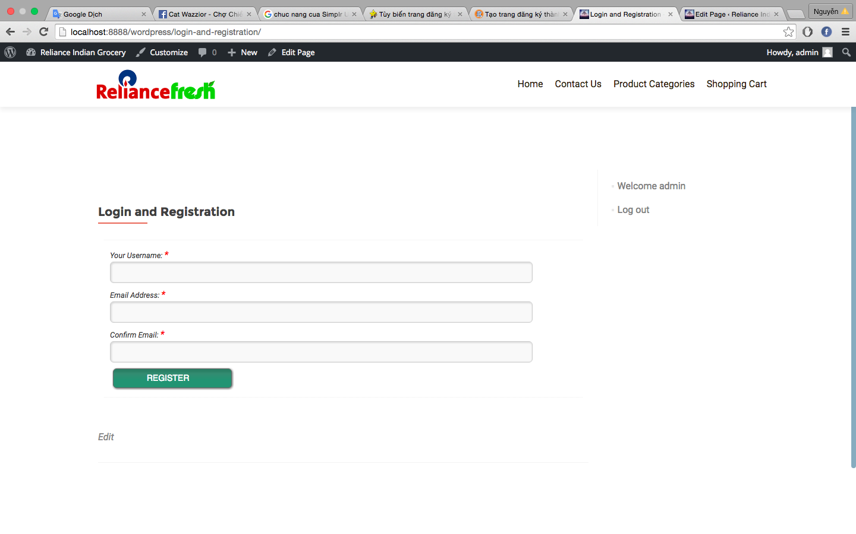

*Figure 2.2: Default Registration form (source: ICT 1 _ Project)*

* *“Simplr User Registration Form Plus”* is a perfect plugin helps you to create a membership registration page completely than the default form of WordPress. Also, this plugin allows you to create a profile page for each member using the shortcode [profile_page].
* After installing and activating the plugin *Simplr User Registration Form Plus”*, you go to **Settings> Registration Form** to proceed the setting.

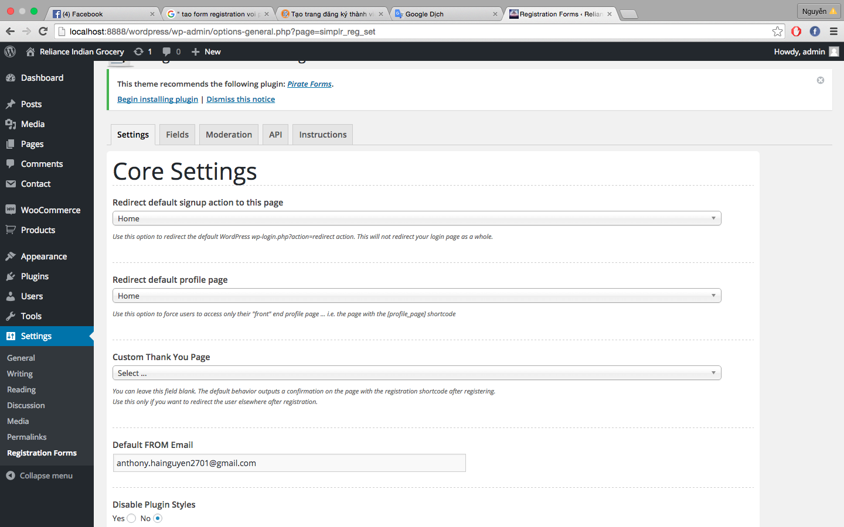

*Figure 2.3: Registration form settings (source: ICT 1 _ Project)*

* On the **Settings** tab, you can set the redirect after membership registration to thank you page or Home page, etc. You can also select Styles for registration form by selecting **No** in the **Disable Plugin Styles** and select Styles in **Select a style** field. Remember filling your email to send mail to members in the **Default FROM Email**.

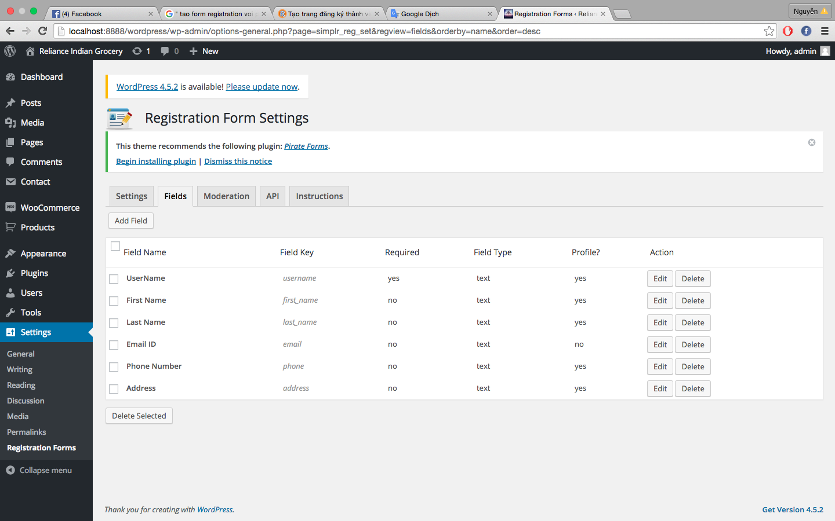

*Figure 2.4: Registration form: Fields settings (source: ICT 1 _ Project)*

* In the **Fields** tab, you can create and manage the information which you want added to the registration page. To create a new field, click **Add Field** and enter content into categories. In **Field Key**, if you want members are required to fill in this information, select **yes** in the field **Is this required?** and otherwise select **No**.

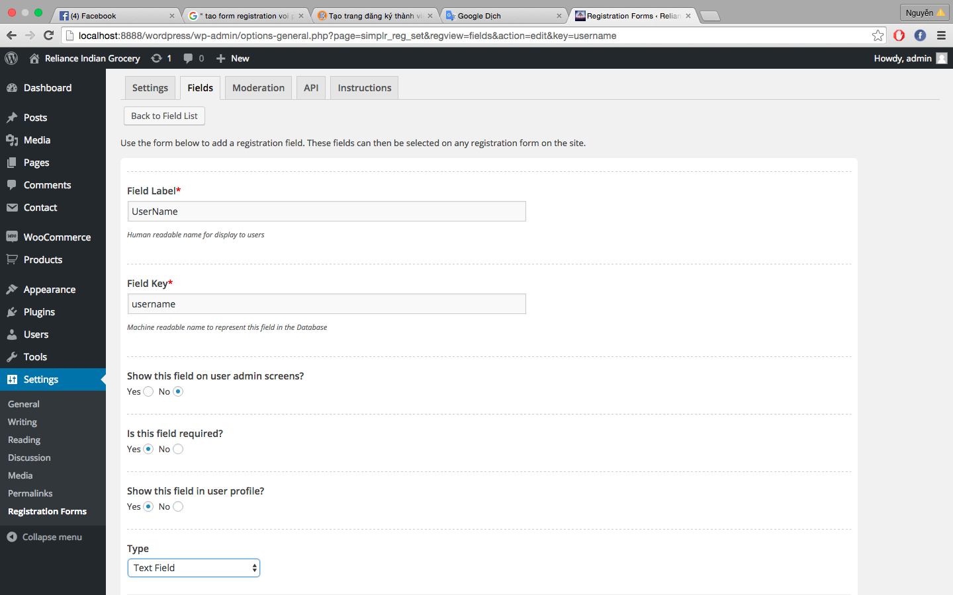

*Figure 2.5: Registration form: Fields settings (source: ICT 1 _ Project)*

* In **Moderation** tab, you can choose to allow members can activate their account via the link sent to their email address or you can manually activate the account for registered users.

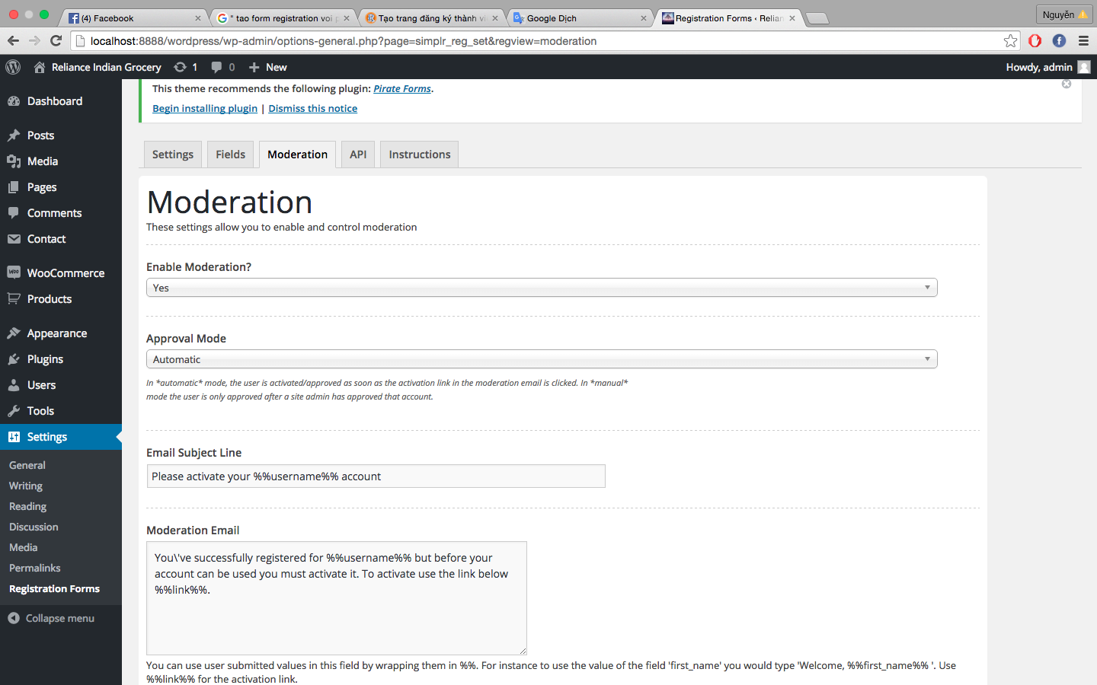

*Figure 2.4: Registration form: Moderation settings (source: ICT 1 _ Project)*

* Finally, **API** tab allows you to activate **captcha** function for the registration form to avoid spam or you can allow members to connect with their Facebook account.

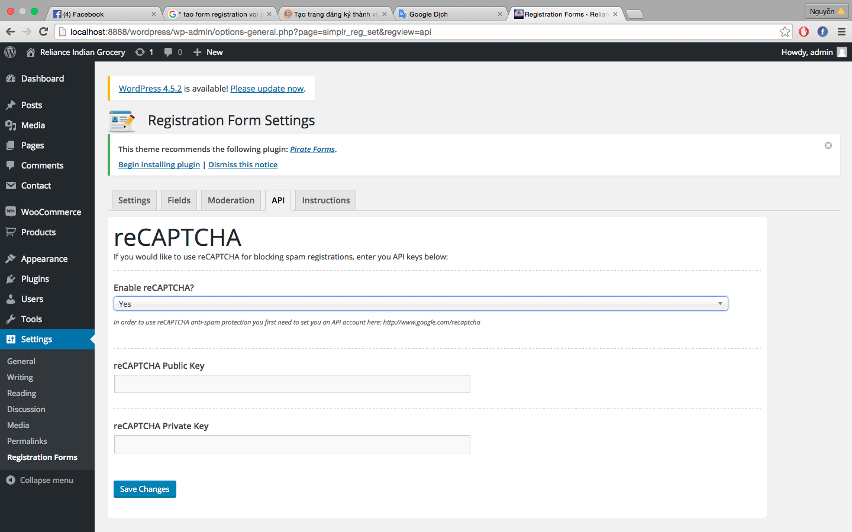

*Figure 2.5: Registration form: API settings (source: ICT 1 _ Project)*

* Now, you just create a new page **“Login and Registration”** on the website, you will see **Add Registration Form** button at the top frame article editor. Click this button to insert the registration form on the site and you get a complete register.

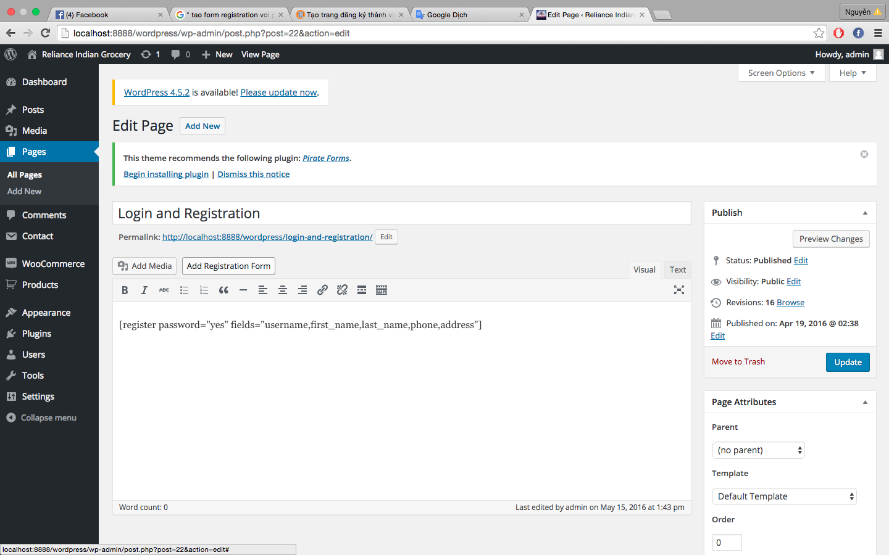

*Figure 2.6: Add Registration form in Registration page (source: ICT 1 _ Project)*

* The result is showed below:

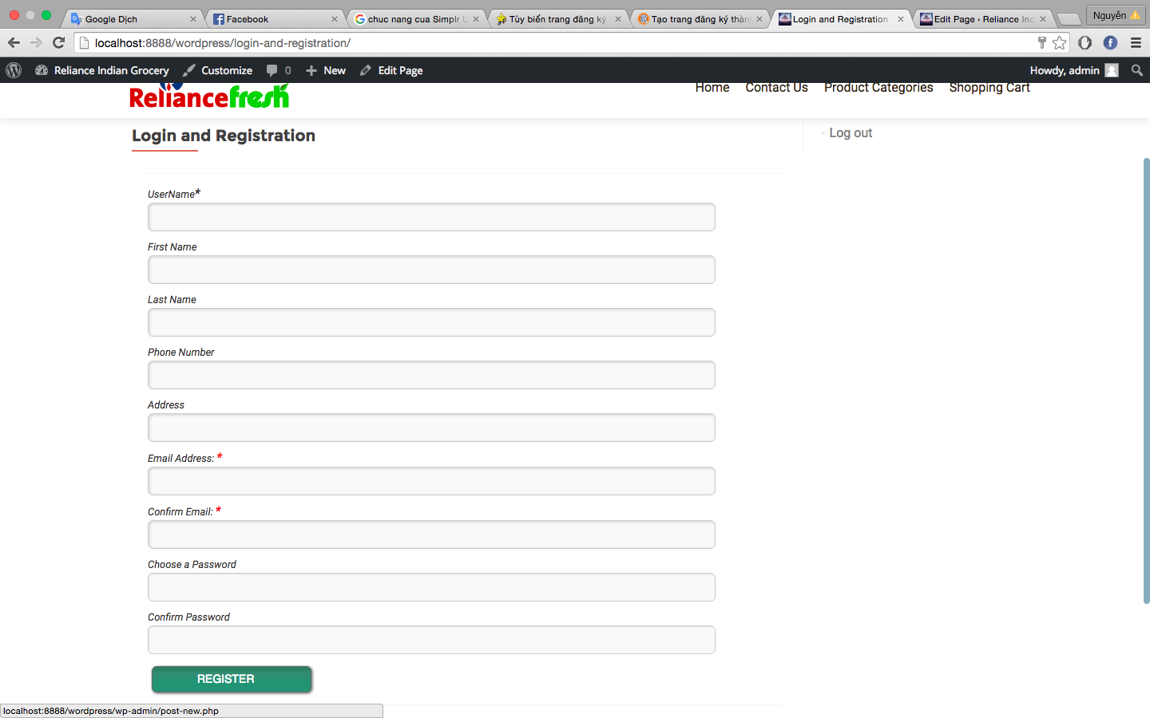

*Figure 2.7: Registration page (source: ICT 1 _ Project)*

* 1. **Login and Logout Plugin:**

The Login-Logout Plugin is downloaded and active in the website. To convenience for users, this Plugin is combined with Widget WordPress to give the link Login and Logout for each page in my Project.

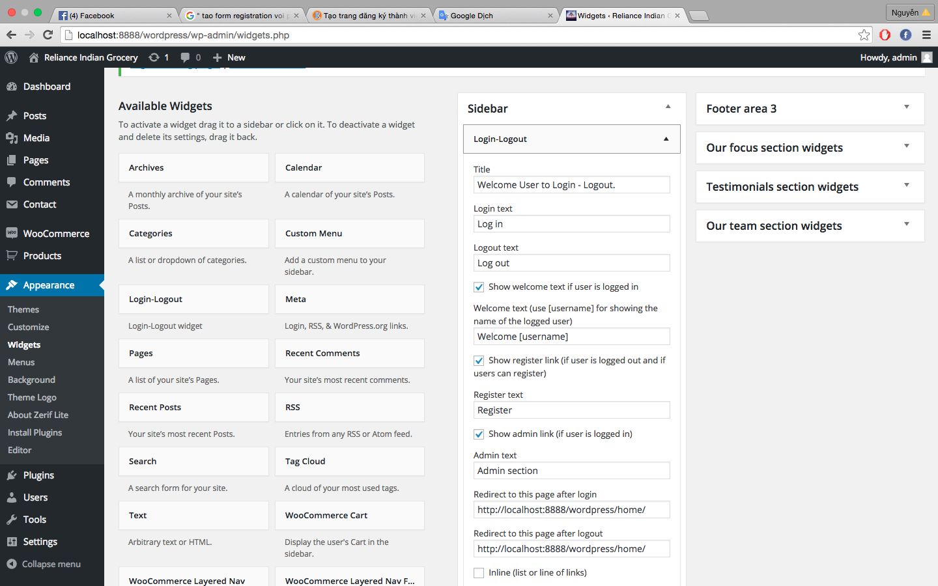

* The result is showed in the right hand side for each page:

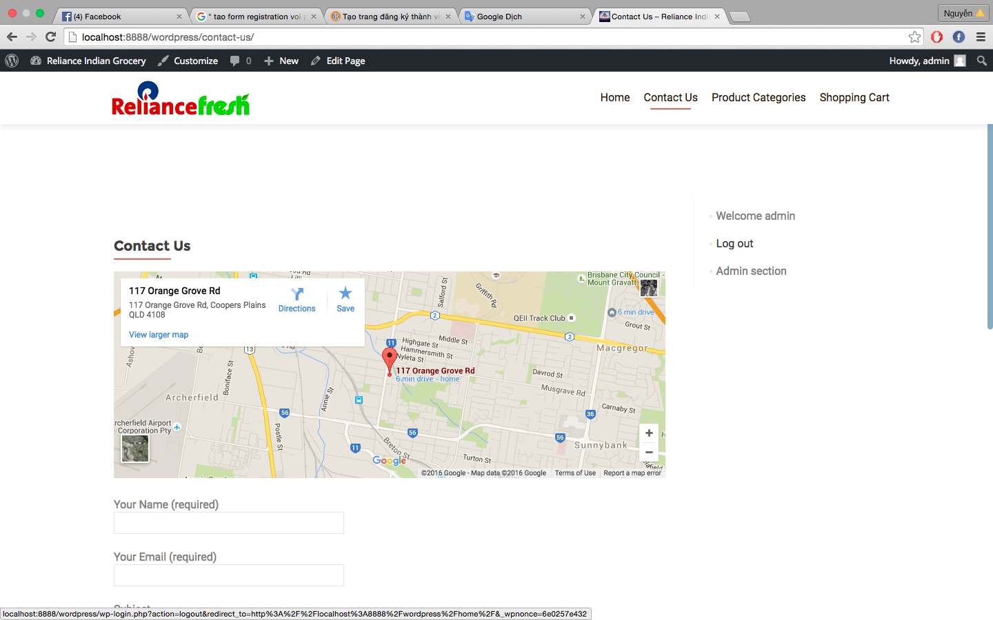

*Figure 2.8: Login-Logout Plugin for Contact Us Page (source: ICT 1 _ Project)*

* 1. Contact Us Page:Using *“contact form 7”* plugin.
* Contact form 7 is a plugin to creates form which is common and is used much by the web designer, with simple usage and satisfy almost the criteria of a form according to the standard website, as well as evaluation of users. Also this plugin supports anti-spam by captcha function to restrict spam mail.

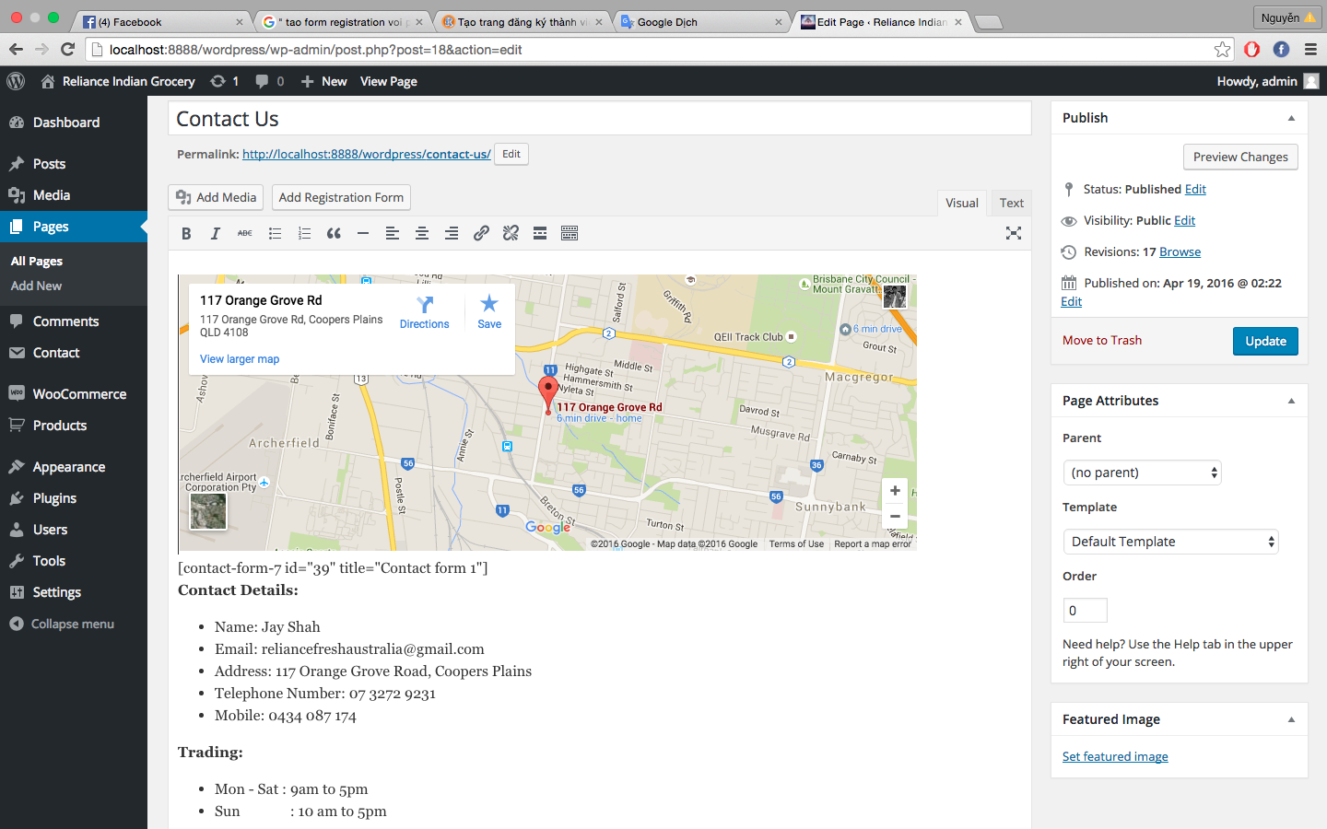

*Figure 2.8: Contact form 7 is active and set in Contact Us page*

* The result is showed below:

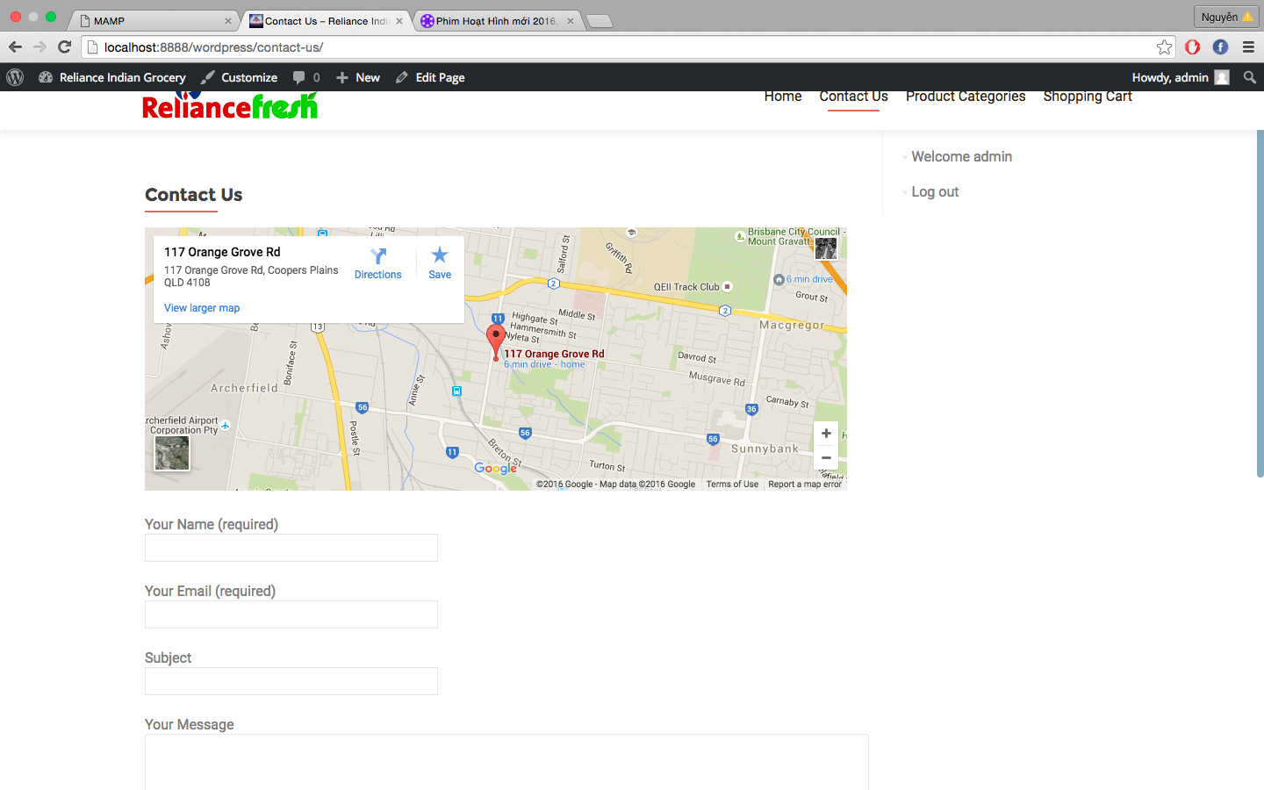

*Figure 2.9: Contact Us page (source: ICT 1 _ Project)*

# Chapter 3: UNDERSTANDING PLUGIN

There are thousands Plugins available in WordPress but we can not abuse and install too many the plugins without understanding. The *“Simplr User Registration Form Plus*” applied to my ICT 1 project, which is the registration form was downloaded from WordPress and demonstrated in this chapter.

## Starting write Plugin for *“Simplr User Registration Form Plus”*.

* **Create folder and files:**

That are the first step in the process of writing plugins. The plugin folder must be placed inside of **plugins** with the link *wp-content/plugins*, then this folder will be able to activate and use.



* **Set the name for folder and files:**

Each plugin has at least two files are the main **PHP** plugin files and **readme.txt** files contain information about the name, version information, as well as other relevant information for the plugin. The purpose of the **readme file** to upload plugin on WordPress.org.

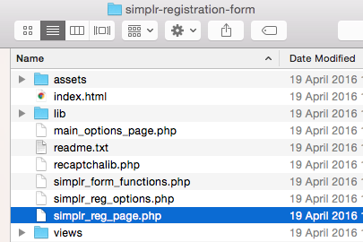

* **Starting write coding for plugin:**

Create header Plugin. The main plugin PHP file needs to put a few notes at the top of the file. These notes include the name of the plugin, the author's name, describes the plugin, version of the plugin and the current links of the plugin home page with the author's home page. More specifically, this creates the basic parts like below:

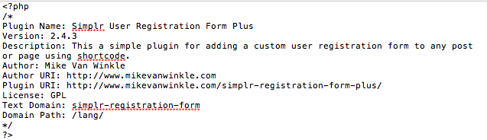

* **Define path for Plugin:**

There are 2 paths:

* Local path: local path: is the physical path to the files and folders on your computer
* URL path: is the path that the user access to the server via web browsers
* **activate the plugin**:

This is a totally new plugin and it's only the name but not the contents inside

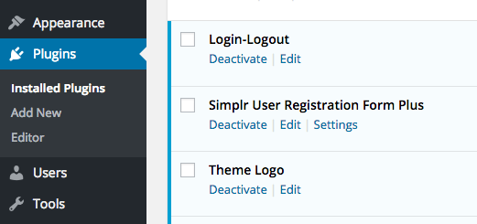

**The formula:**

*register_activation_hook ($file, $function);*

🡪 $file: path to Plugin file

🡪 $function: the function will be executed when the Plugin active.

**The purpose of active Plugin:**

* Create default values and save to *wp_option* in database of WordPress
* Create new files in database to store data which Plugin created.
* **Deactivate Plugin:**

**The formula:**

*register_deactivation_hook ($file, $function);*

🡪 $file: path to Plugin file

🡪 $function: the function will be executed when the Plugin deactivate.

**The purpose of deactivate Plugin:**

* Deactivate Plugin
* Change some values in *wp_option*
* **Uninstall Plugin:**

**The formula:**

*register_uninstall_hook ($file, $function);*

🡪 $file: path to Plugin file

🡪 $function: the function will be executed when the Plugin uninstall.

**The purpose of uninstall Plugin:**

* Remove Plugin: delete the default values in *wp_option* and delete all the file in database
* The WordPress will help in removing that Plugin

**CASE STUDY:**

Through this section, I have learned how to create folders and files as well as how to declare information for a plugin prior to going into the code.

## Writing code for Plugin.

* Write a plugin using shortcode and action Hook to call the function “*simplr_reg_install()”*

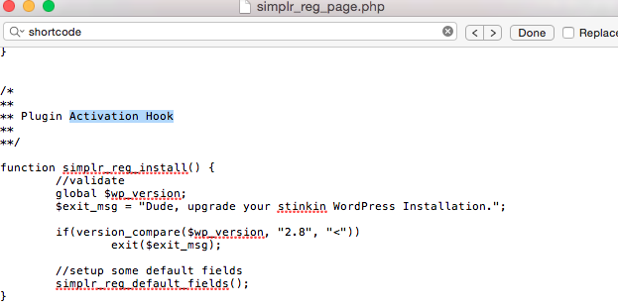

* Testing Plugin after finishing code

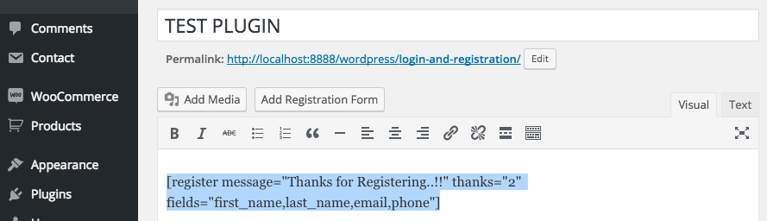

**CASE STUDY:**

There are many ways to write Plugin but in this section, I have learned how to write Plugin using Shortcode which is most popular by number of users. Shortcode also supports to post music to the posts. Sometimes, adding a HTML code into Plugin, but WordPress does not allow to do so, then we use the shortcode to do this.

## Complete and Upload Plugin to WordPress.

* Insert HTML, CSS and JavaScript into Plugin.
* Upload plugin to WordPress using **Readme.txt**

**CASE STUDY:**

This is an important step, not everyone can put their plugin on WordPress servers. To do that, your plugin must be undergoing a very strict process checking. Therefore, the results depend on the process of your learning, if you master the theory and apply proficiency in building a plugin, the plugin will be accepted quickly by WordPress. Conversely, if your plugin has no value or there are too many errors, then WordPress will reply to you with suggestions for revised appropriate plugin.

## Testing Plugin:

* Test on the local host.
* Test on the online host.
* Check malware through each attachment.
* Subscribe version of plugin to know that this plugin has been updated regularly.
* Check the evaluation of other users.

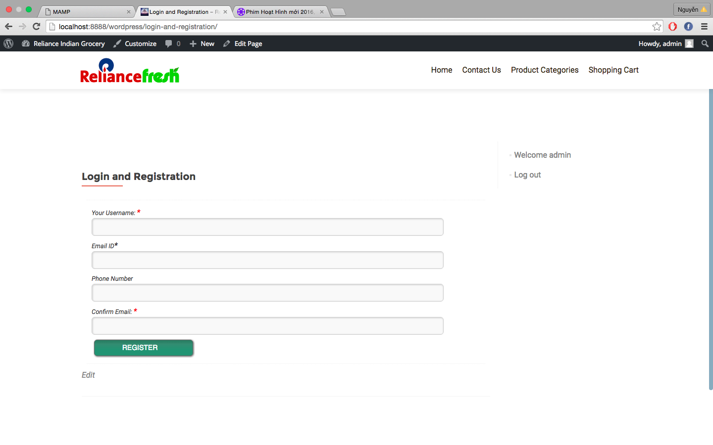

*Figure 3.1: Registration page (source: ICT 1 _ Project)*

# CONCLUSION.

Plugin is an indispensable component in using WordPress and make the powerful for WordPress. Therefore, the choice of good and helpful plugins will increase security capabilities and help speed load page faster.

In this report, the users can get an overview of the Plugin as well as its influence in helping WordPress went and stood first position in the ranking of source blogging. Also giving case study based on the understanding of Plugin and apply it to our ICT1_Project.

# RECOMENDATIONS.

Plugin helps website represents the functionality that you are desirable but not so that you can not abuse and install too many the plugins. You should only install the necessary plugins. The installation of multiple Plugins will make your website become less secure and slower. the recommendation is that Plugin on the WordPress is safety because it has passed moderated and publicly posted on the homepage by moderator. So you should use the plugin posted on it and restrict the use of external plugins unidentified authors and code inside.

# REFERENCES

Balkhi, S. (2009). WPBeginner. Retrieved from http://www.wpbeginner.com/glossary/plugin/#

Brazell, A. (2011). WordPress Bible. John Wiley and Sons.

Codex, W. (2014). Settings API. Viitattu,.

Olinik, M., & Armitage, R. J. (2011). *The WordPress Anthology*. SitePoint.

PINGDOM. (2012). WordPress completely dominates top 100 blogs. Retrieved from http://royal.pingdom.com/2012/04/11/wordpress-completely-dominates-top-100-blogs/

Prelovac, V. (2009). WordPress Plug-in Development (Beginner's Guide). Packt Publishing Ltd.

Ratnayake, R. N. (2015). *WordPress Web Application Development*. Packt Publishing Ltd.

Sabin-Wilson, L., Miller, C., Palmer, K., Rennick, A., & Torbert, M. (2011).*WordPress All-in-one for Dummies*. John Wiley & Sons.

Suharto, E., & Guerrero, A. T. Handling Variability in Open Source Software. *9th SC@ RUG 2011-2012*, 29.

Wang, H. A., Lin, Y. C., Lu, H. T., & Lin, S. T. (2012). Open Source for Web-Based Video Editing. *Journal of Information Science and Engineering*, *28*(4), 787-801.

Lerch, A., Eisenberg, G., & Tanghe, K. (2005). FEAPI: A low level feature extraction plugin API. In *Proceedings of 8th International Conference on Digital Audio Effects* (pp. 73-76).

Ji, J., Kim, J., Kim, Y., Jung, S., Lee, C., Kim, D., ... & Lim, H. Design and Implementation of the Korean Style Plug-In using the Wordpress.

Wang, H. A., Lin, Y. C., Lu, H. T., & Lin, S. T. (2012). Open Source for Web-Based Video Editing. *Journal of Information Science and Engineering*, *28*(4), 787-801.